|  |  |  |  |  |  |  |  |  |
| --- | --- | --- | --- | --- | --- | --- | --- | --- |
| **Form GSTR-1 [See rule 59(1)]** | | | | | | | | |
|  | | | | | | | | |
| **Details of outward supplies of Goods or Services** | | | | | | | | |
| **Financial year:** | | | | **Tax Period:** | | | | |
|  | | | | | | | | |
| **GSTIN No.:** | | | | | | | | |
| **Legal Name of the Registered Person:** | | | | | | | | |
| **Trade Name if any:** | | | | | | | | |
| **ARN:** | | | | **Date of ARN:** | | | | |
| (Amount in ₹ for all tables) | | | | | | | | |
| **Description** | **No. of Records** | **Document type** | **Taxable Value** | **Integrated Tax** | | **Central Tax** | **State / UT Tax** | **CESS** |
| 4A - Taxable outward supplies made to registered persons (other than reverse charge supplies) - B2B Regular | | | | | | | | |
| Total |  |  |  |  | |  |  |  |
|  | | | | | | | | |
| 4B - Taxable outward supplies made to registered persons attracting tax on reverse charge - B2B Reverse Charge | | | | | | | | |
| Total |  |  |  |  | |  |  |  |
|  | | | | | | | | |
| 5A - Taxable outward inter-state supplies to made unregistered persons (where invoice value more than Rs. 2.5 lakh) -B2CL (Large) | | | | | | | | |
| Total |  |  |  |  | |  |  |  |
|  | | | | | | | | |
| 6A - Exports (with / without payment) | | | | | | | | |
| Total |  |  |  |  | |  |  |  |
| - EXPWP |  |  |  |  | |  |  |  |
| - EXPWOP |  |  |  |  | |  |  |  |
|  | | | | | | | | |
| 6B - Supplies made to SEZ unit or SEZ developer - SEZWP / SEZWOP | | | | | | | | |
| Total |  |  |  |  | |  |  |  |
| - SEZWP |  |  |  |  | |  |  |  |
| - SEZWOP |  |  |  |  | |  |  |  |
|  | | | | | | | | |
| 6C - Deemed Exports -- DE | | | | | | | | |
| Total |  |  |  |  | |  |  |  |
|  | | | | | | | | |
| 7 - Taxable supplies (Net of debit and credit notes) to unregistered persons (other than the supplies covered in table 5) - B2CS (others) | | | | | | | | |
| Total |  |  |  |  | |  |  |  |
|  | | | | | | | | |
| 8 - Nill rated, Exempted and Non-GST outward supplies | | | | | | | | |
| Total |  |  |  |  | |  |  |  |
| - Nil |  |  |  |  | |  |  |  |
| - Exempted |  |  |  |  | |  |  |  |
| - Non-GST |  |  |  |  | |  |  |  |
|  | | | | | | | | |
| **\*Note* NDA - Net Differential Amount** | | | | | | | | |
| 9A - Amendment to taxable outward supplies made to registered persons in returns of earlier tax periods in table 4 - B2B Regular | | | | | | | | |
| Amended Amount - Total |  |  |  |  | |  |  |  |
| NDA (Amended - Original) |  |  |  |  | |  |  |  |
|  | | | | | | | | |
| 9A - Amendment to taxable outward supplies made to registered persons in return of earlier tax periods in table 4 - B2B Reverse charge | | | | | | | | |
| Amended Amount - Total |  |  |  |  | |  |  |  |
| NDA (Amended - Original) |  |  |  |  | |  |  |  |
|  | | | | | | | | |
| 9A - Amendment to taxable outward supplies made to registered persons (where invoice value is more than Rs. 2.5 lakh) in return of earlier tax periods in table 5- B2CL (Large) | | | | | | | | |
| Amended Amount - Total |  |  |  |  | |  |  |  |
| NDA (Amended - Original) |  |  |  |  | |  |  |  |
|  | | | | | | | | |
| 9A - Amendment to Export supplies in returns of earlier tax periods in table 6A (EXPWP / EXPWOP) | | | | | | | | |
| Amended Amount - Total |  |  |  |  | |  |  |  |
| NDA (Amended - Original) |  |  |  |  | |  |  |  |
| - EXPWP |  |  |  |  | |  |  |  |
| - EXPWOP |  |  |  |  | |  |  |  |
|  | | | | | | | | |
| 9A - Amendment to supplies made to SEZ units or SEZ developers in ruturns of earlier tax periods in table 6B (SEZWP / SEZWOP) | | | | | | | | |
| Amended Amount - Total |  |  |  |  | |  |  |  |
| NDA (Amended - Original) |  |  |  |  | |  |  |  |
| - SEZWP |  |  |  |  | |  |  |  |
| - SEZWOP |  |  |  |  | |  |  |  |
|  | | | | | | | | |
| 9A - Amendment to Deemed Exports in returns of earlier tax periods in table 6C (DE) | | | | | | | | |
| Amended Amount - Total |  |  |  |  | |  |  |  |
| NDA (Amended - Original) |  |  |  |  | |  |  |  |
|  | | | | | | | | |
| **\*Note* Dr - Debit Note Cr - Credit Note** | | | | | | | | |
| 9B - Credit / Debit Notes (Registered) - CDNR | | | | | | | | |
| Total - Net off Dr/Cr (Dr-Cr) |  |  |  |  | |  |  |  |
| Credit / Debit notes issued to registered persons for taxable outward supplies in table 4 other than table 6 - B2B regular | | | | | | | | |
| Net Total (Dr-Cr) |  |  |  |  | |  |  |  |
| Credit / Debit notes issued to registered persons for taxable outward supplies in table 4 other than table 6 - B2B Reverse Charge | | | | | | | | |
| Net Total (Dr-Cr) |  |  |  |  | |  |  |  |
| Credit / Debit notes issued to registered persons for taxable outward supplies in table 6B - SEZWP / SEZWOP | | | | | | | | |
| Net Total (Dr-Cr) |  |  |  |  | |  |  |  |
| Credit / Debit notes issued to registered persons for taxable outward supplies in table 6C - DE | | | | | | | | |
| Net Total (Dr-Cr) |  |  |  |  | |  |  |  |
|  | | | | | | | | |
| 9B - Credit / Debit Notes (Unregistered) - CDNUR | | | | | | | | |
| Total - Net off Dr/Cr (Dr-Cr) |  |  |  |  | |  |  |  |
| Unregistered Type | | | | | | | | |
| - B2CL |  |  |  |  | |  |  |  |
| - EXPWP |  |  |  |  | |  |  |  |
| - EXPWOP |  |  |  |  | |  |  |  |
|  | | | | | | | | |
| **\*Note* NDA - Net Differential Amount NADr - Net Amended Debit Notes NACr - Net Amended Credit Notes** | | | | | | | | |
| 9C - Amended Credit / Debit Notes (Registered) - CDNRA | | | | | | | | |
| Amened Amount - Total |  |  |  |  | |  |  |  |
| NDA (NADr - NACr) - Total |  |  |  |  | |  |  |  |
| Amended Credit / Debit notes issued to registered persons for taxable outward supplies in table 4 other than table 6 - B2B regular | | | | | | | | |
| Net Total (NADr - NACr) |  |  |  |  | |  |  |  |
| Amanded Credit / Debit notes issued to registered persons for taxable outward supplies in table 4 other than table 6 - B2B Reverse Charge | | | | | | | | |
| Net Total (NADr - NACr) |  |  |  |  | |  |  |  |
| Amanded Credit / Debit notes issued to registered persons for taxable outward supplies in table 6B - SEZWP / SEZWOP | | | | | | | | |
| Net Total (NADr - NACr) |  |  |  |  | |  |  |  |
| Amanded Credit / Debit notes issued to registered persons for taxable outward supplies in table 6C - DE | | | | | | | | |
| Net Total (NADr - NACr) |  |  |  |  | |  |  |  |
|  | | | | | | | | |
| 9C - Amended Credit / Debit Notes (Unregistered) - CDNURA | | | | | | | | |
| Amended Amount - Total |  |  |  |  | |  |  |  |
| NDA (NADr - NACr) - Total |  |  |  |  | |  |  |  |
| Unregistered Type | | | | | | | | |
| - B2CL |  |  |  |  | |  |  |  |
| - EXPWP |  |  |  |  | |  |  |  |
| - EXPWOP |  |  |  |  | |  |  |  |
|  | | | | | | | | |
| 10 - Amendment to taxable outward supplies made to unregistered persons in returns for earlier tax periods in table 7 - B2C (Others) | | | | | | | | |
| Amended Amount - Total |  |  |  |  | |  |  |  |
| NDA (Amended - Original) |  |  |  |  | |  |  |  |
|  | | | | | | | | |
| 11A(1) , 11A(2) - Advances received for which invoices has not been issued (tax amount to be added to the output tax liability) (Net of Refund Vouchers) | | | | | | | | |
| Total |  |  |  |  | |  |  |  |
|  | | | | | | | | |
| 11B(1), 11B(2) - Advance amount received in earlier tax period and adjusted against the supplies being shown in this tax period in Table Nos. 4,5,6 &7 | | | | | | | | |
| Total |  |  |  |  | |  |  |  |
|  | | | | | | | | |
| 11A - Amendment to advances received in returns for earlier tax periods in table 11A(1), 11A(2) | | | | | | | | |
| Amended Amount - Total |  |  |  |  | |  |  |  |
| Total |  |  |  |  | |  |  |  |
|  | | | | | | | | |
| 11B - Amendment to advances adjusted in returns for earlier tax periods in table 11B(1), 11B(2) | | | | | | | | |
| Amended Amount - Total |  |  |  |  | |  |  |  |
| Total |  |  |  |  | |  |  |  |
|  | | | | | | | | |
| 12 - HSN-wise summary of outward supplies | | | | | | | | |
| Total |  |  |  |  | |  |  |  |
|  | | | | | | | | |
| 13 - Documents issued | | | | | | | | |
| Net issued Documents |  |  |  |  | |  |  |  |
|  | | | | | | | | |
| **Total Liability (Outward supplies other than Reverse Charge)** | | |  |  | |  |  |  |
|  | | | | | | | | |
| Verification: | | | | | | | | |
|  | | | | | | | | |
|
|  | | | | | | | | |
| **Date:** | | **Designation / Status** | | | **Name of Authorized Signatory** | | | |
|  | |  | | |  | | | |

[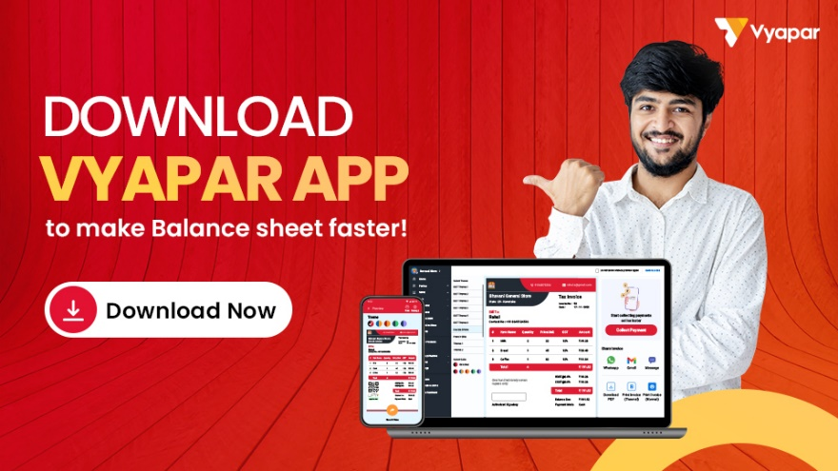](https://billing.vyaparapp.in/format)