Company/Seller Name: |  |  |  |  |  | LOGO
Address :
Phone No.:
Email ID:
GSTIN:
State:
Tax Invoice
Bill To: |  |  |  | Shipping To:
Name:
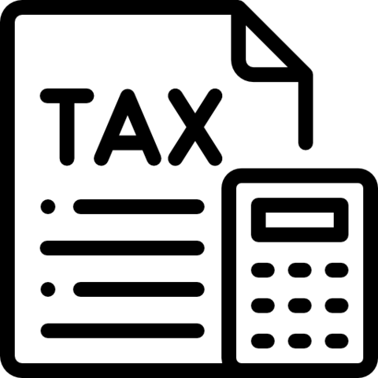
Address:

Contact No.: |  |  |  | Invoice No.: |  | ABC-2022-0001
GSTIN No.: |  |  |  | Date: |  | DD/MM/YYYY
State:
# | Item name | Quantity | Unit | Price/  Unit | Discount | GST | Amount
1 | Item1 | 1 | 2 | ₹ 200.00 | 20 | 5% | 189
2 | Item 2 | 1 | 4 | ₹ 250.00 | 10 | 18% | 283.2
3 | Item 3 | 1 | 6 | ₹ 340.00 | 20 | 5% | 336
4 | Item 4 | 1 | 5 | ₹ 300.00 | 30 | 5% | 283.5
5 | Item 5 | 1 | 7 | ₹ 300.00 | 30 | 5% | 283.5
6 | Item 6 | 1 | 8 | ₹ 300.00 | 10 | 5% | 304.5
7 | Item 7 | 1 | 8 | ₹ 200.00 | 20 | 5% | 189
Total |  | 7 |  |  | 140 | 118.70 | 1869
Amount in words: |  |  |  | Sub Total: |  |  | 1890.00
 |  |  |  | Discount: |  |  | 140
 |  |  |  | SGST |  |  | 59.35
 |  |  |  | CGST |  |  | 59.35
 |  |  |  | Total |  |  | 1868.7
Terms & Conditions |  |  |  | Received |  |  | 1868.7
 |  |  |  | Balance |  |  | 0.00
 |  |  |  | Company seal and Sign


